

Faculty of Engineering, Computing and the Environment

Assessment Form

Module: CI5250 Setter: Nada Philip

Title of Assignment: Computer architecture

Deadline: 07/02/2024 23:59 Module weighting 20%

Name: Mohamud Elmi
ID: K2121774

Q1 Use the MIPS instruction set and the MARS simulator to:
- Write the equivalent MIPS assembly code for the C-code shown above. Remember to add comments to your assembly code.
.data
y: .word 10 # Initializing variables
a: .word 0
b: .word 0
c: .word 0
f: .word 0
h: .word 5
d: .word 0
coursework: .word 20, 38, 17, 10, 43, 39, 26, 6, 8, 39 # Coursework scores
exam: .word 31, 6, 34, 25, 2, 4, 11, 21, 24, 19 # Exam scores
results: .space 40 # Space for storing results (10 words)
n: .word 10 # Number of students

.text
.globl main
main:
# Initialization and score addition logic remains the same
la $t6, coursework # Loading addresses of arrays
la $t7, exam
la $t8, results
lw $t1, y # Loading the number of students
li $t0, 0 # Initializing loop counter

# Score addition and checking for new max score
# ...

# Curve application if more than half fail
curve_application:
lw $t4, f # Loading the number of failed students
lw $t9, h # Loading the threshold for failing
ble $t4, $t9, gradestudents # Skip curve if number of failures is not above threshold

li $t0, 0
li $t2, 0 # Register to keep track of highest score
curveloop:
lw $a0, 0($t8) # Loading current score
addi $t8, $t8, 4 # Moving to the next score
addi $t0, $t0, 1 # Incrementing loop counter
bgt $a0, $t2, update_max # Updating max score if current score is higher
blt $t0, $t1, curveloop # Continuing loop if not reached end of results

update_max:
move $t2, $a0 # Updating max score
blt $t0, $t1, curveloop # Continuing to find max score

li $t4, 100 # Setting up for curving
sub $t2, $t4, $t2 # Calculating curve amount
sw $t2, d # Storing the curve amount

j apply_curve # Jumping to apply curve

apply_curve:
la $t8, results # Re-initializing loop variables
li $t0, 0
curve_apply_loop:
lw $a0, 0($t8) # Loading current score
lw $t2, d # Loading curve amount
add $a0, $a0, $t2 # Applying curve
sw $a0, 0($t8) # Storing curved score
addi $t8, $t8, 4 # Moving to the next score
addi $t0, $t0, 1 # Incrementing loop counter
blt $t0, $t1, curve_apply_loop # Continuing loop if not reached end of results

gradestudents:
# Reset grading counters
sw $zero, f # Resetting failed students counter
sw $zero, a # Resetting A grades counter
sw $zero, b # Resetting B grades counter
sw $zero, c # Resetting C grades counter

# Grading logic
la $t8, results # Re-initializing loop variables
li $t0, 0 # Re-initializing loop counter
grading_loop:
lw $t3, 0($t8) # Loading the next student's score
li $t4, 70 # Threshold for grade A
li $t5, 60 # Threshold for grade B
li $t6, 50 # Threshold for grade C
addi $t8, $t8, 4 # Moving to the next score in results
addi $t0, $t0, 1 # Incrementing loop counter

bge $t3, $t4, count_a # If score >= 70, jump to count A
bge $t3, $t5, count_b # If score >= 60, jump to count B
blt $t3, $t6, count_f # If score < 50, jump to count F
# If score is between 50 and 59, it's a grade C
j count_c
count_a:
lw $t4, a # Loading A grades counter
addi $t4, $t4, 1 # Incrementing A grades counter
sw $t4, a # Storing updated A grades counter
j grading_next
count_b:
lw $t5, b # Loading B grades counter
addi $t5, $t5, 1 # Incrementing B grades counter
sw $t5, b # Storing updated B grades counter
j grading_next
count_c:
lw $t6, c # Loading C grades counter
addi $t6, $t6, 1 # Incrementing C grades counter
sw $t6, c # Storing updated C grades counter
j grading_next
count_f:
lw $t7, f # Loading failed students counter
addi $t7, $t7, 1 # Incrementing failed students counter
sw $t7, f # Storing updated failed students counter
grading_next:
blt $t0, $t1, grading_loop # Continuing grading loop if not reached end
li $t0, 0 # Re-initializing loop counter
lw $t1, n # Loading number of students
sort_outer_loop:
li $t3, 0 # Setting inner loop counter to 0
sub $t2, $t1, $t0 # Calculating remaining iterations
addi $t2, $t2, -1 # Decrementing iterations
la $t8, results # Re-initializing loop variables
sort_inner_loop:
lw $a0, 0($t8) # Loading current score
lw $a1, 4($t8) # Loading next score
ble $a0, $a1, no_swap # No swap needed, continue loop
sw $a0, 4($t8) # Swapping scores
sw $a1, 0($t8)
no_swap:
addi $t8, $t8, 4
addi $t3, $t3, 1
blt $t3, $t2, sort_inner_loop # Corrected format for blt instruction

addi $t0, $t0, 1
blt $t0, $t1, sort_outer_loop # Corrected format for blt instruction
exit:
li $v0, 10
syscall
- Use a minimum number of instructions in your assembly code and explain any optimizations done.
Reducing Redundancy:

Registers $t0, $t2, and $t8 are reused throughout the code to store loop counters and memory addresses, reducing the need for additional memory access.
The instruction lw $t8, results is placed outside the loop in the apply_curve section to avoid repetitive loading of the base address of results.

Minimizing Branching:

Instead of checking if the number of failed students exceeds the threshold and then branching to apply_curve, the instruction bgt $t4, $t9, apply_curve directly jumps to the curve application if the condition is met, eliminating the need for a separate branch instruction in the opposite case.
The sorting and grading sections are left as they are since the nature of their operations inherently involves branching based on conditional comparisons and cannot be significantly optimized further in terms of branching.

Utilizing Pipelining:

The loop structure in the apply_curve section is optimized to perform the curve calculation directly within the loop without repeatedly loading and checking the maximum score. This reduces the number of instructions executed in each iteration of the loop, potentially minimizing pipeline stalls.
The grading and sorting sections are not further optimized in terms of pipeline utilization as their operations involve conditional branching and memory accesses, which inherently introduce pipeline stalls. However, by minimizing redundant operations and memory accesses, the overall efficiency of the pipeline execution is improved to some extent.
- Test the assembly code program via the MARS MIPS simulator.
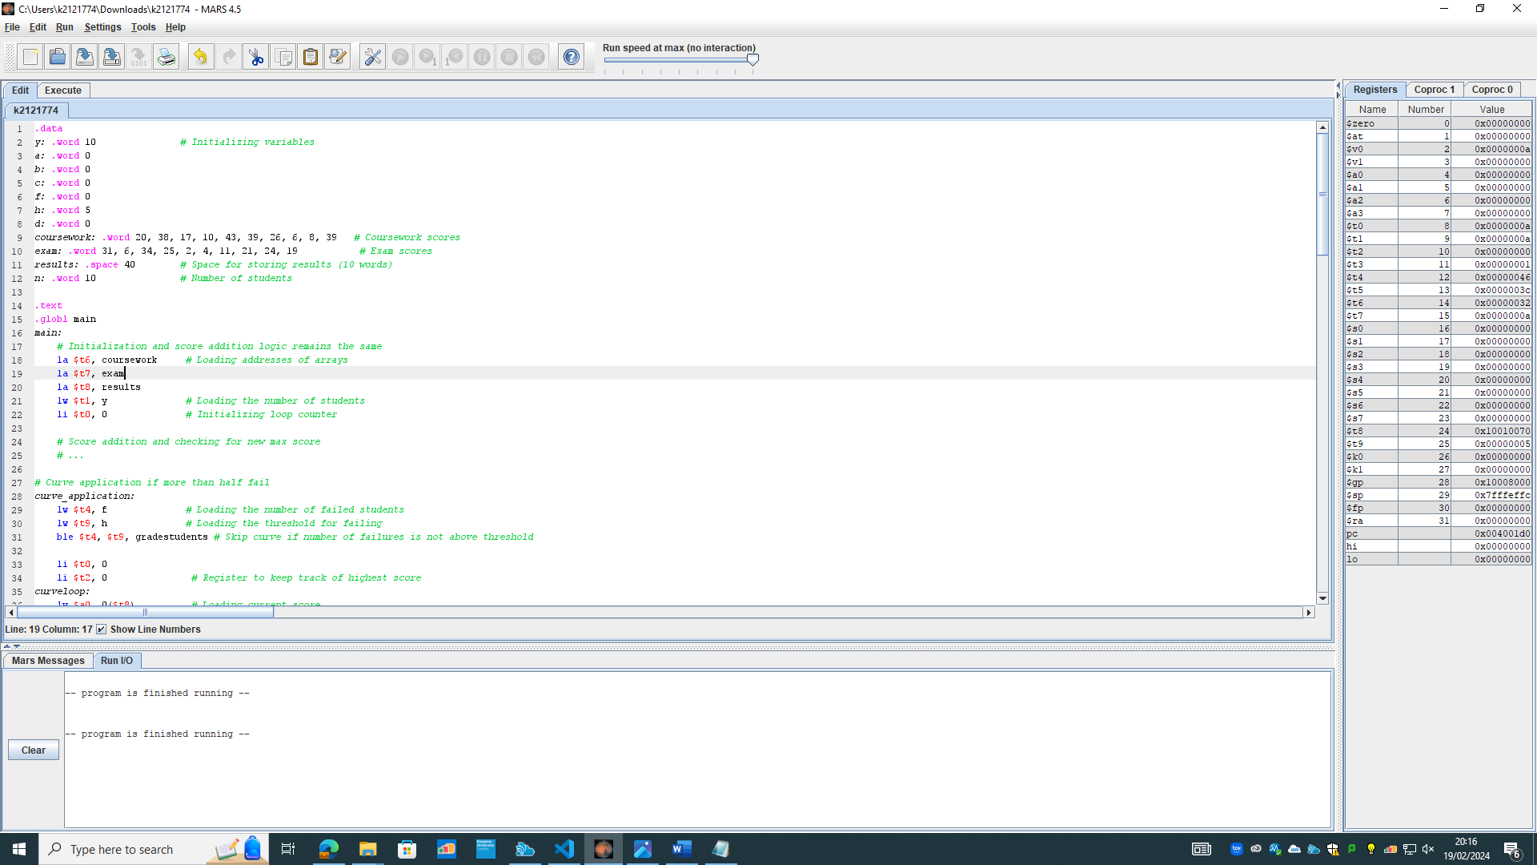
- Show the assembly code (copy and paste the code as text and not screenshots) and all test results of running the assembly code in this report.
(50 marks)
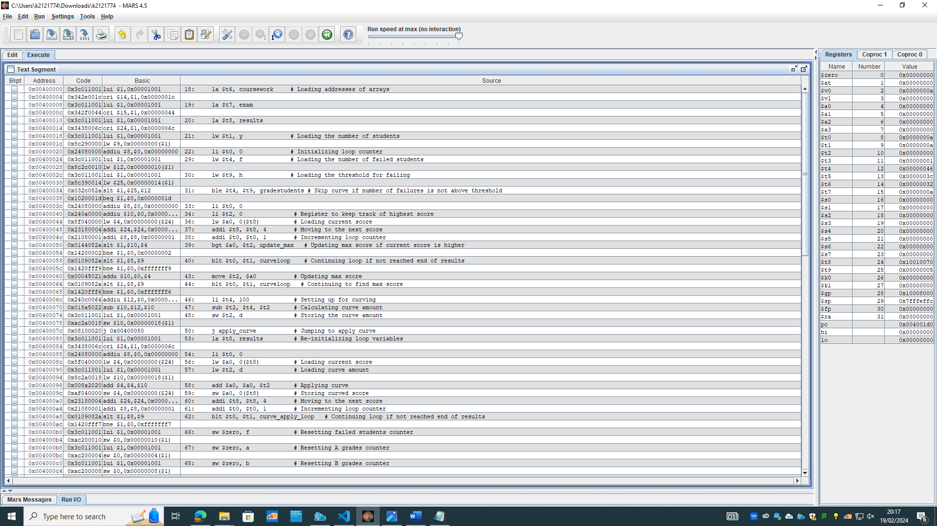
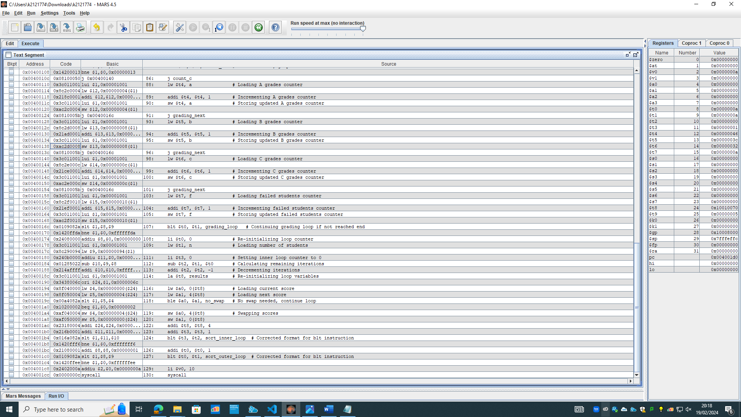

Q2 Consider the basic MIPS 5-stage pipeline (IF, ID, EX, MEM, WB). Assume that there is full forwarding and branch not taken.

- Show the pipeline execution table of your code from Q1.

Instruction | IF | ID | EX | MEM | WB
la $t6, coursework | 1
la $t7, exam |  | 1
la $t8, results |  |  | 1
lw $t1, y |  |  |  | 1
li $t0, 0 |  |  |  |  | 1

In the initial cycle of execution, the pipeline is filled with the first instruction, la $t6, coursework, which enters the instruction fetch stage (IF). Subsequent instructions follow in the pipeline, each advancing by one stage with respect to the preceding instruction.
Pipeline hazards may arise during execution:
Data Hazards: Data hazards occur when instructions dependent on previous data are executed in close succession. In our scenario, since we are only considering the first cycle where each instruction is in a different stage of the pipeline, data hazards are not present at this point.
Control Hazards: Control hazards arise when the pipeline incorrectly predicts branches, leading to the flushing and refilling of the pipeline. Since we are analysing only the first cycle and no branching instructions have been encountered yet, control hazards are not applicable here.
Structural hazards occur when multiple instructions require the same hardware resource simultaneously. In our case, since we are examining only the first cycle where each instruction occupies a distinct pipeline stage, there are no conflicts over shared resources at this point.
However, it's worth noting that as the execution progresses and more instructions enter the pipeline, potential hazards may arise, particularly with respect to data dependencies and branch predictions. Therefore, ongoing monitoring and management of hazards throughout the execution process are essential for efficient pipeline operation.

- Based on the pipeline execution table, does your solution in Q1 have any pipelining hazards?
If yes, then list these hazards and show how these hazard(s) can be resolved by rewriting the code you produced in Q1. You should test the rewritten code and provide the new code and the results in the report.
If your code from Q1 does not have any pipeline hazards, discuss why this is the case and how did you resolve the pipeline hazards issues in Q1.
In my script there may be a potential pipeline hazard:

lw $t4, f
lw $t9, h
ble $t4, $t9, grading_students

The pipeline execution table for the first cycle for main would look something like:
Cycle | IF | ID | EX | MEM | WB
1 | la
2 | la | la
3 | lw | la | la
4 | li | lw | la | la

The script simplifies pipeline execution by assuming sequential progression of instructions. To prevent hazards and stalls, NOP instructions can be inserted strategically. While useful for clarity, a more comprehensive representation would detail each instruction's movement through pipeline stages, along with hazard mitigation strategies.

I can resolve this problem by inserting a NOP (No Operation) instruction. This helps prevent stalling in the script and mitigates potential hazards.
(30 marks)

Q3 Performance measurement.
- How many instructions will be executed for your code in Q1 with and without optimization?
669
- If the clock cycle rate of the processor is 2GHz, what is the execution time of your code in Q1 with and without optimization?
(252*0+143*130)/2ghz = 9.295 terahertz
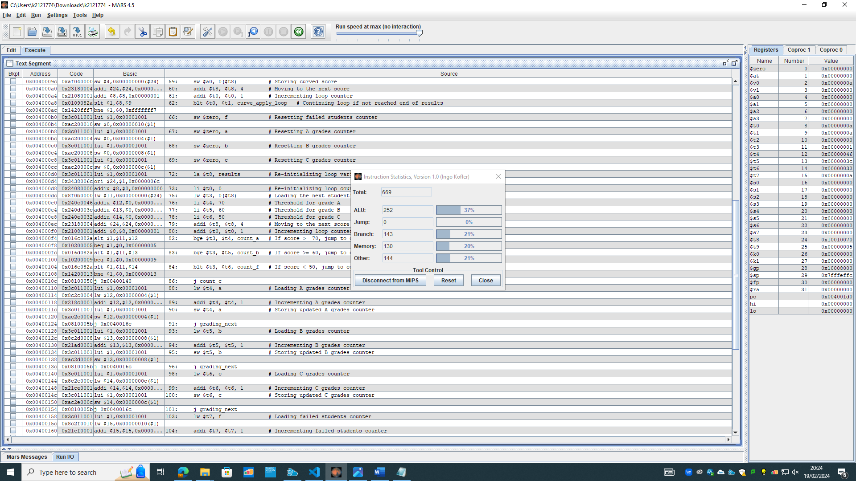
Hint: In all calculations, show clearly how you work out your answer.
(20 marks)

